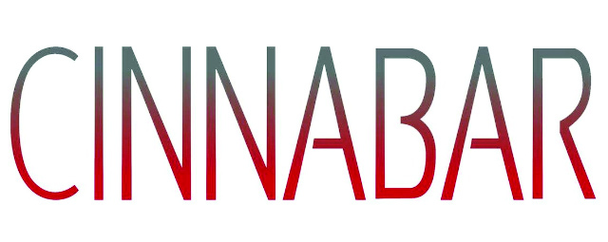

Johnston Foster
CV

EDUCATION

2005 MFA Hunter College
2003 Skowhegan School of Painting & Sculpture
2001 BFA Virginia Commonwealth University

SOLO EXHIBITIONS

2015 Hidden Driveway RARE Gallery, New York , New York
2014 Highbreeds The Blender Gallery, Athens, Greece (w/ Dionisios Fragias)
2012 Galeria Christopher Paschall, Bogota, Colombia
The Natural RARE Gallery, New York, New York
2011 Head Stash POVevolving Gallery, Los Angeles, California
Selected Specimens Flippo Gallery, Randolph-Macon College, Ashland, Virginia
Monolith Drifts Disjecta, Portland, Oregon
Foggy Notions Rocky Mountain College of Art + Design, Denver, Colorado
2010 Centre d’Art Bastille (fka Lieu d’Images d’Art), Grenoble, France
Catch & Release RARE, New York, New York
2009 Sticky Situation Crest Gallery of Art, University of Tennessee/Chattanooga
galerieXprssns, Hamburg, Germany
2008 Johnston Foster: Altered Beast Contemporary Art Center of Virginia, Virginia Beach, Virginia
Summertime Blues RARE, New York, New York
2007 Lieu d’Images et d’Art (LIA) Grenoble, France
Seasons in the Abyss Illinois State University Galleries, Normal, Illinois
2006 Season in the Abyss Emergency Arts, New York, New York
Delusions of Grandeur RARE, New York, New York
2005 Disenchanted Forest Brigham Young University, Museum of Art, Provo, Utah
Celebrate the New Dark Age Futura Gallery, Prague, Czech Republic
2004 The Permanent Vacation Project Room, PS 1 Contemporary Art Center, Long Island City, New York
The Last Resort RARE, New York, New York
Plot Thickener Ipanema Gallery, Richmond, Virginia
Trouble Everyday Virginia Commonwealth Gallery, Richmond, Virginia

